**Aim:** Explain the process of configuring Jenkins on Windows platform and run a small GitHub project.

**Answer:**

1. Downloading Jenkins.war file from <https://www.jenkins.io/download/>

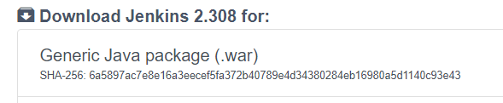

1. 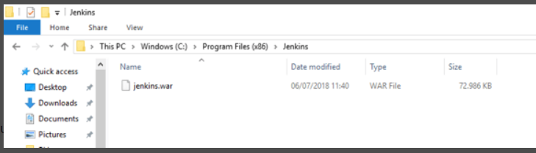Copying the downloaded Jenkins.war file to preferred location.
2. Opening the Command Prompt in this location and executing the command-

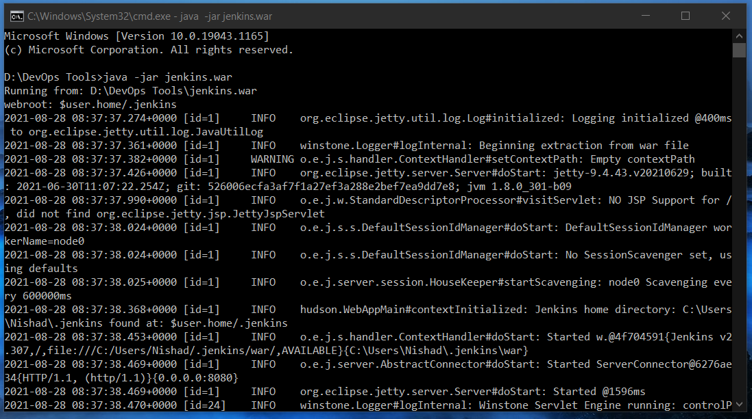 **Java -jar Jenkins.war**

1. Waiting till the Jenkins is successfully installed and returns a status-

**“Jenkins is fully up and running”**

1. 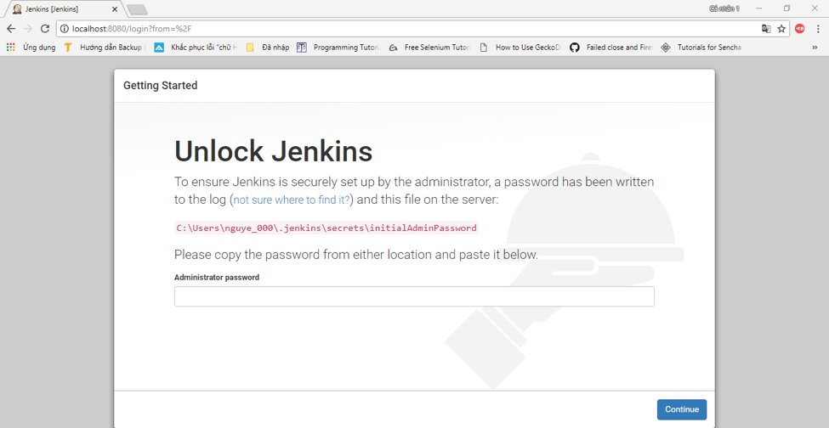Going to the [**http://localhost:8080/**](http://localhost:8080/)to confirm the Jenkins home page.
2. 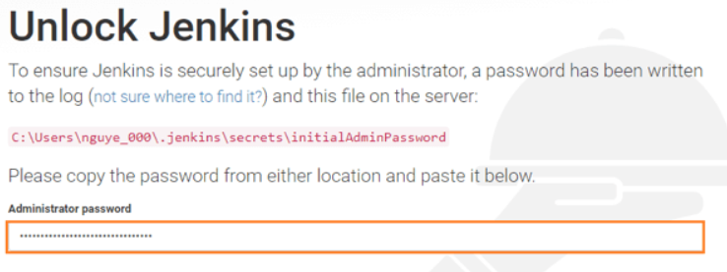Pasting the authorization key from the given location and initializing Jenkins with default plugins.

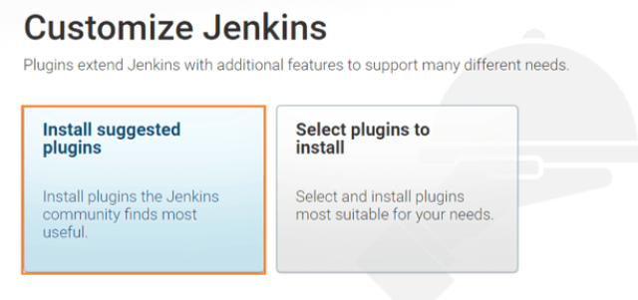

1. 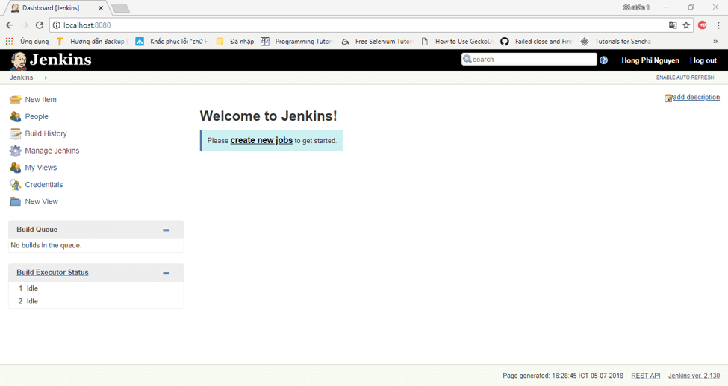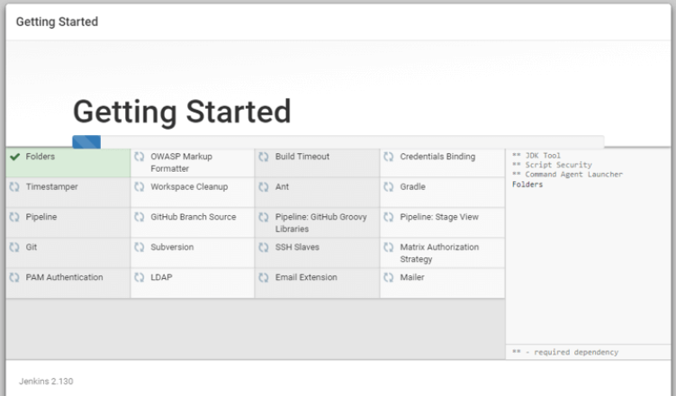Jenkins home page after complete setup.
2. 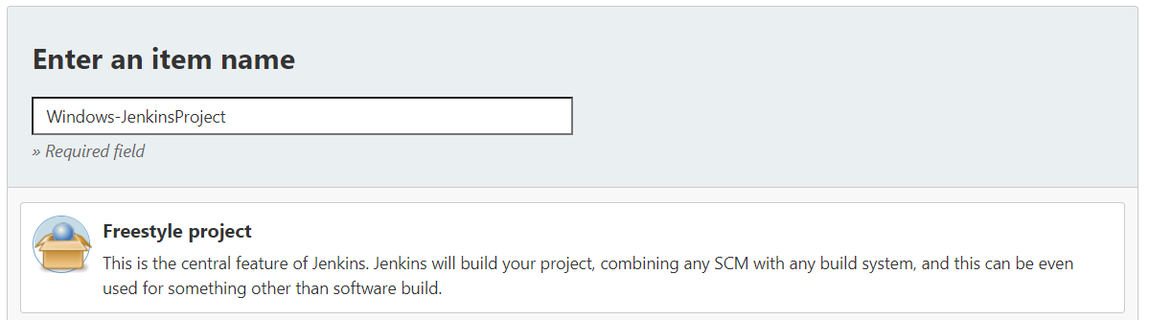Building a sample project in Jenkins from GitHub.

